**Tools Required** – Filezilla

**Application** – Veeva CRM

**Process Steps:**

1. Install Filezilla to your local system (C🡪Users🡪CWID)
2. Go to Edit and click on Settings

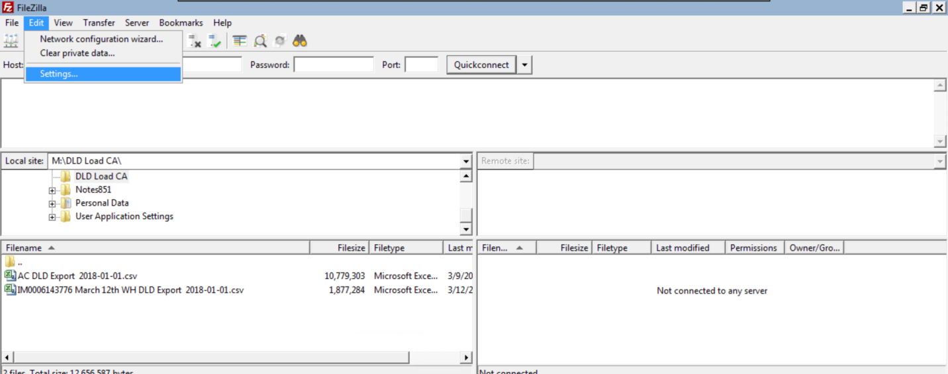

1. Under Connection, click on Generic Proxy
2. Enter the proxy settings as given below with bayer network credentials and click ok

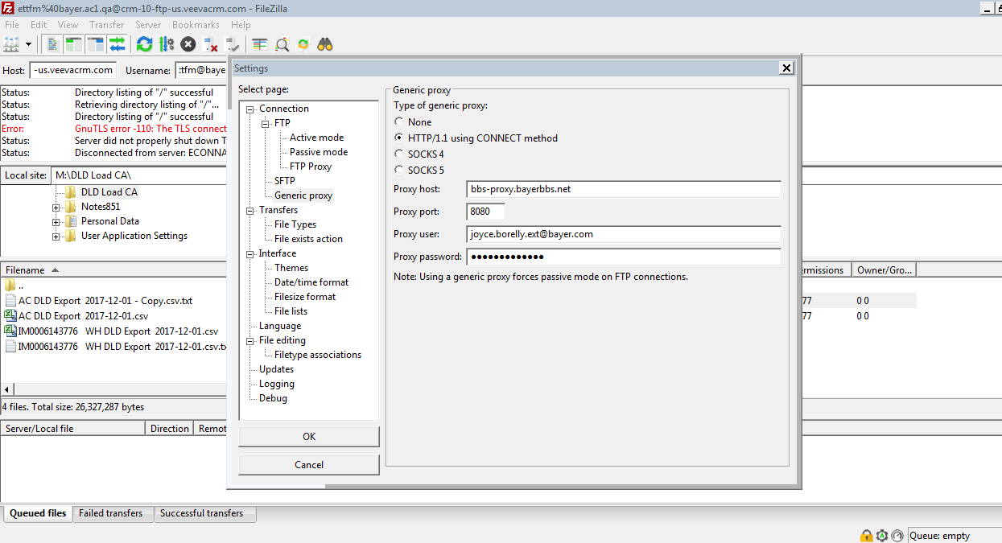

1. Login to Veeva CRM for the relevant Environment🡪Setup🡪Custom Settings🡪Veeva Common🡪Manage🡪Main🡪Copy the FTP Server url (without https)

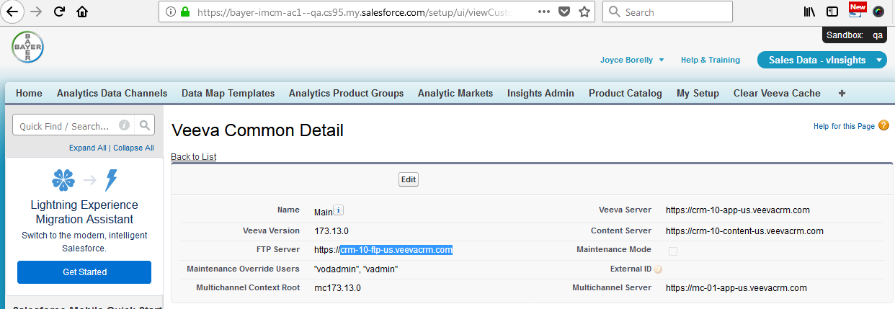

1. Paste the copied url to the Host in Filezilla, enter CRM Environment Credentials and click on Quickconnect. Connection will be established

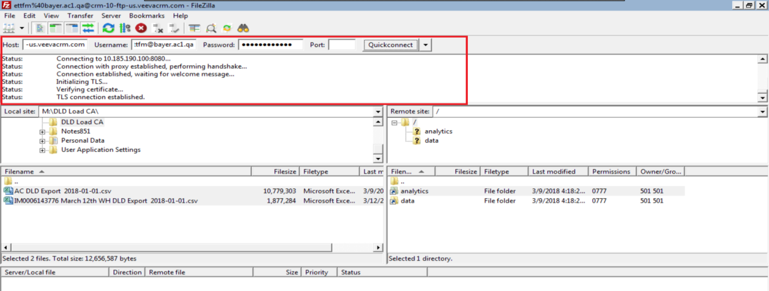

1. Click on Analytics on the right side. Following folders will be displayed.

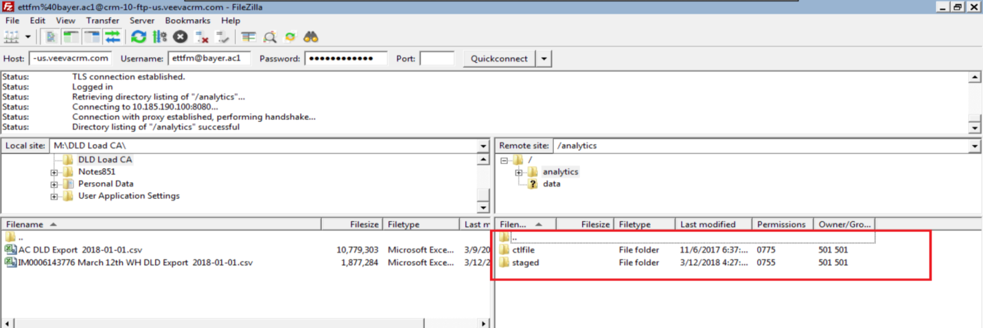

1. Go to Veeva CRM🡪Sales Data –vInsights App🡪Insights Admin Tab. Clear all the files.

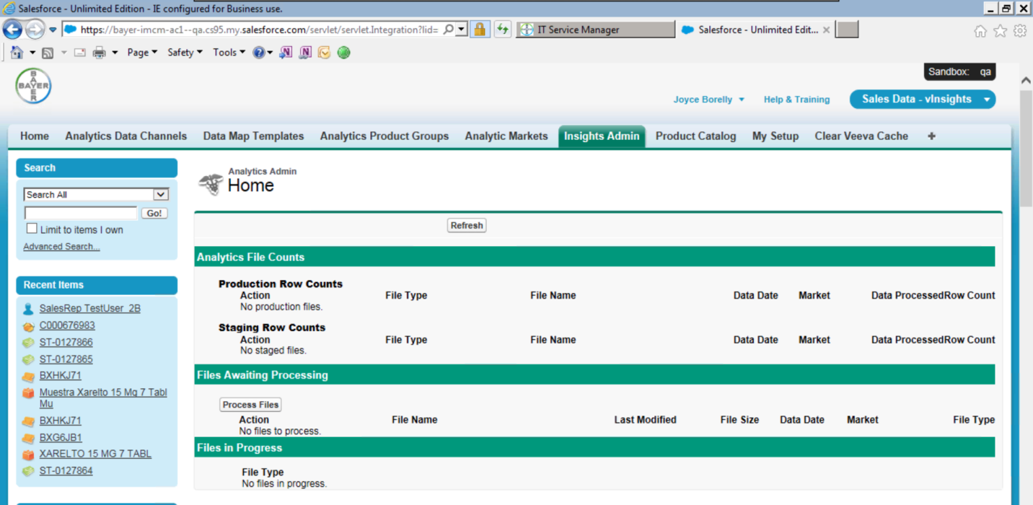

1. Go back to Filezilla. Select the files on the left that are to be processed and drag them to the right, below the staged files

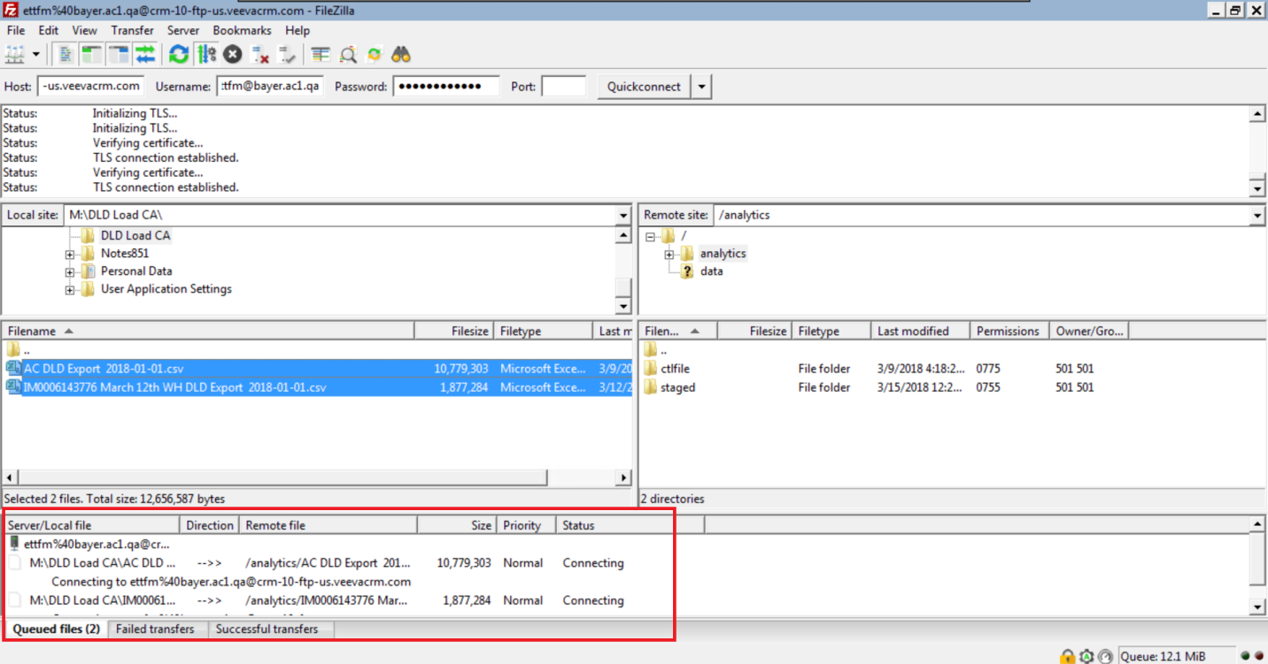

1. Files will be transferred successfully as below

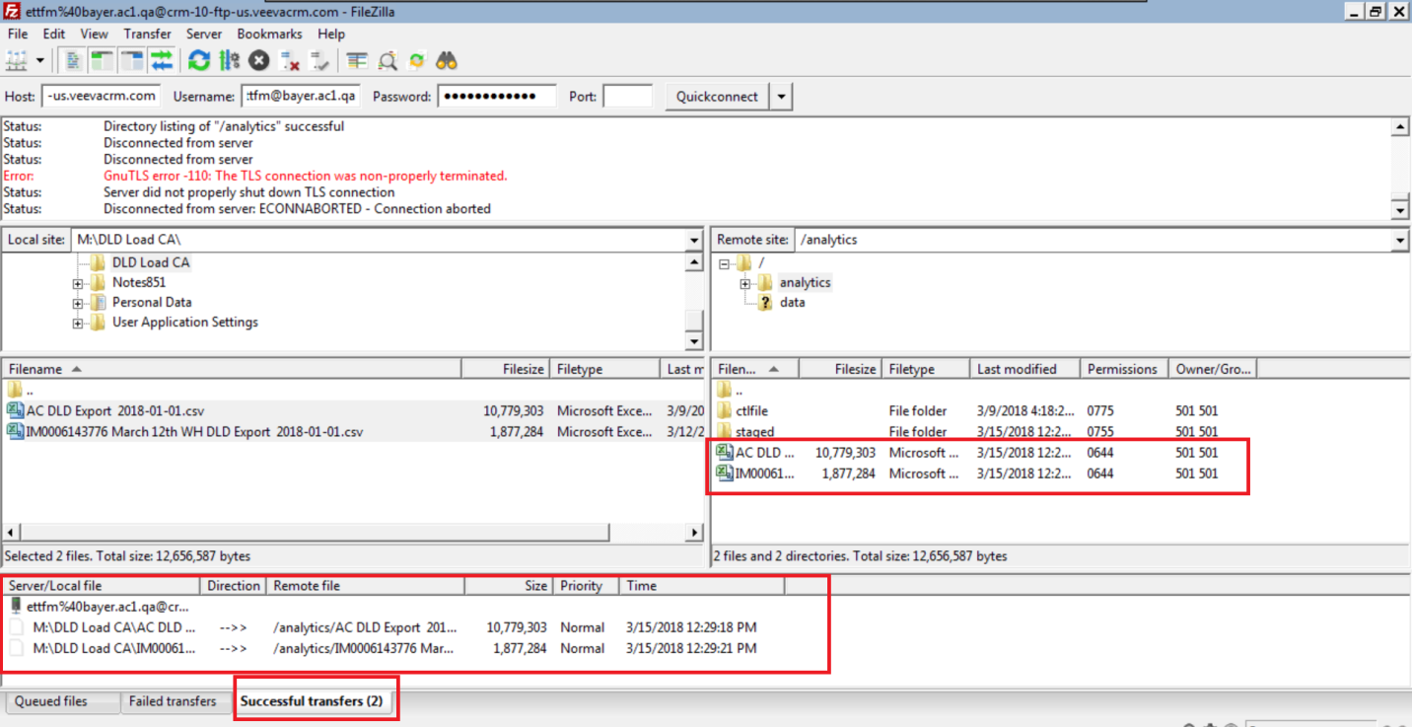

1. Go to Veeva CRM🡪Insights Admin Tab. Files that are for processing, will be showing as below

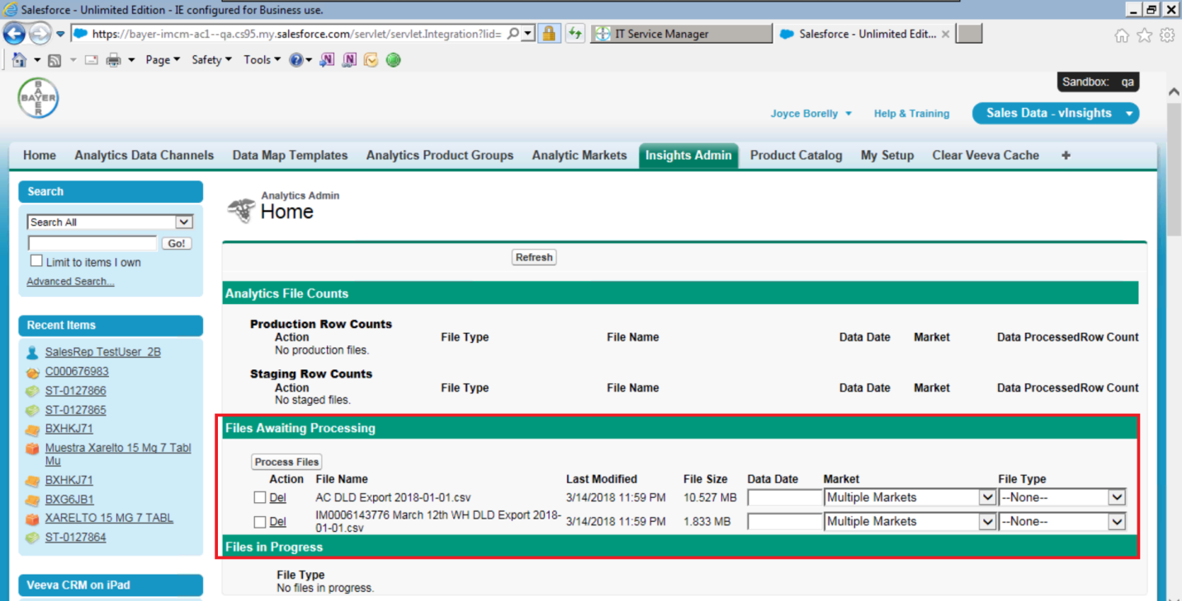

1. To process the file, enter relevant date (from the file name), select the market(from the file name again) and file type accordingly.

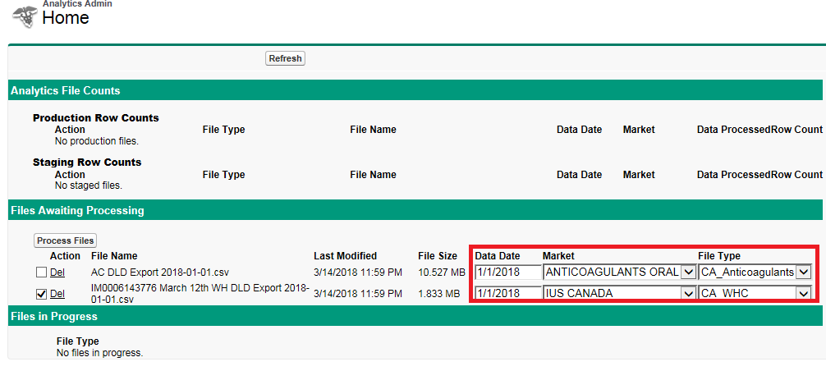

1. Check the check box on and click on Process Files
2. Check if the file is in ‘Files in Progress’ Section

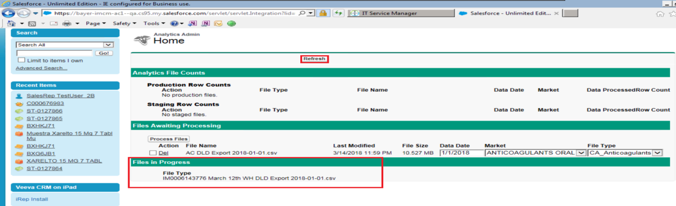

1. Click on Refresh button and the file will move to staging section as below

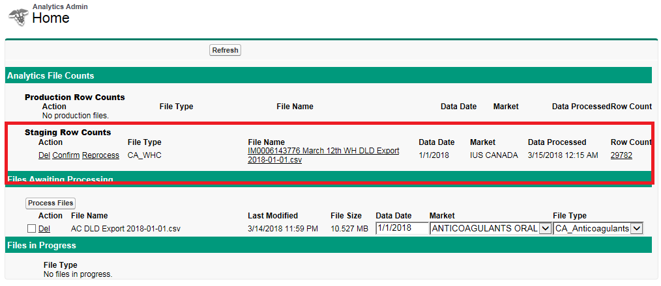

1. Click on the Row count and check if the details are in the proper format and copy the id value and keep it for reference later.

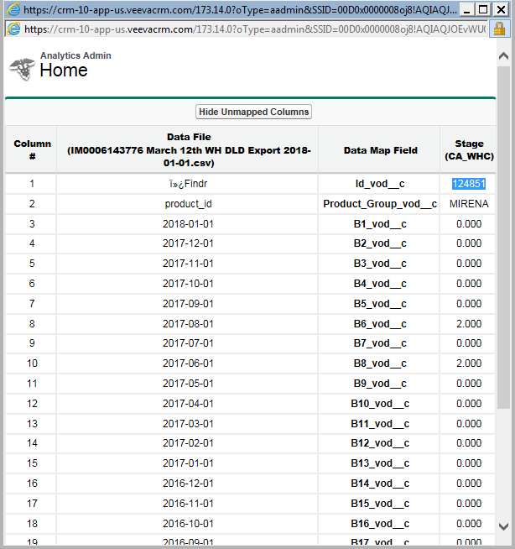

1. Close the window and click on Confirm for processing
2. The file will move from staging to production Row counts section

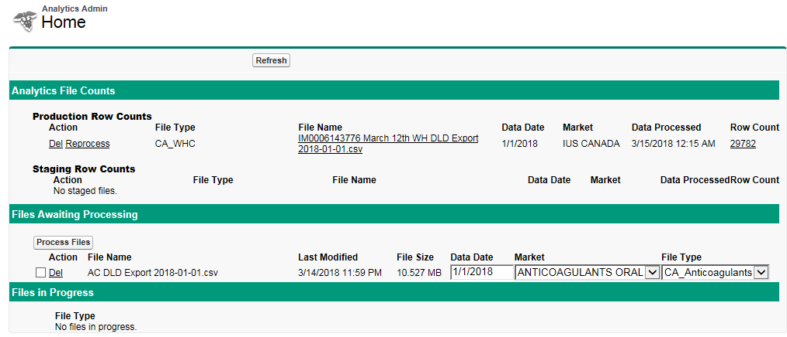

1. Emails will be generated and sent to your email box as below

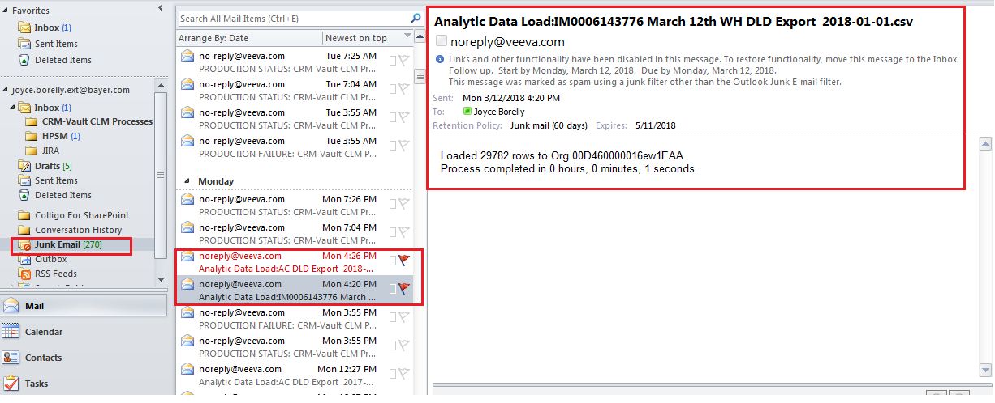

1. To check if the file has loaded successfully, go to reports and make a report as below and enter the id copied from step 14 in the filter and run the report.

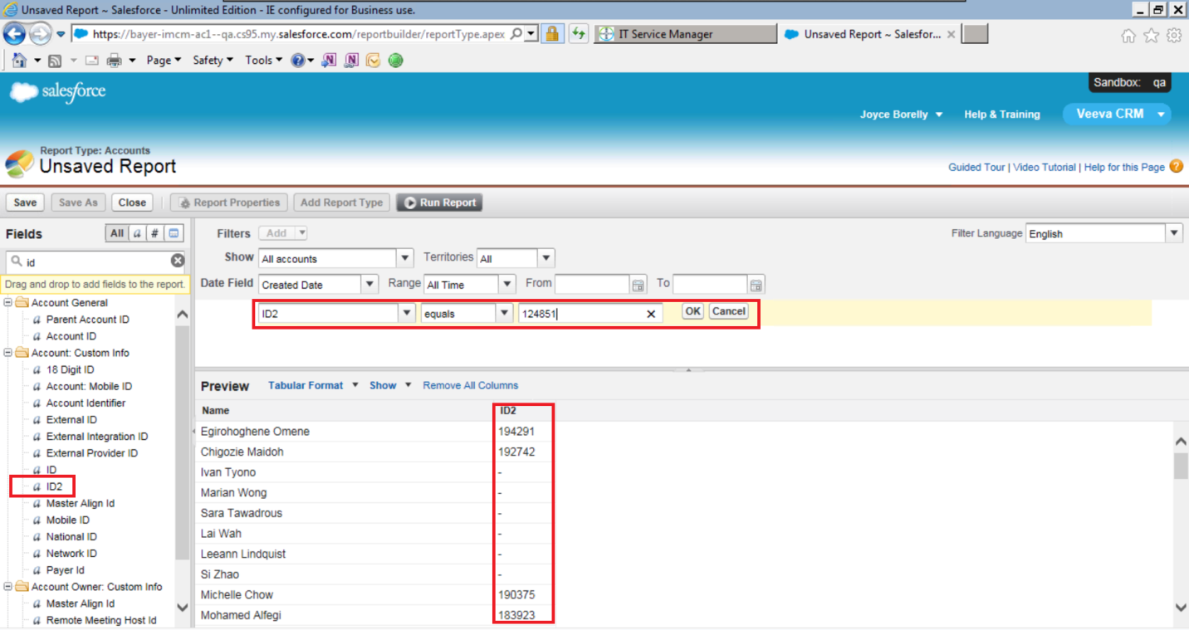

1. Click on the account name and click on the account summary button.

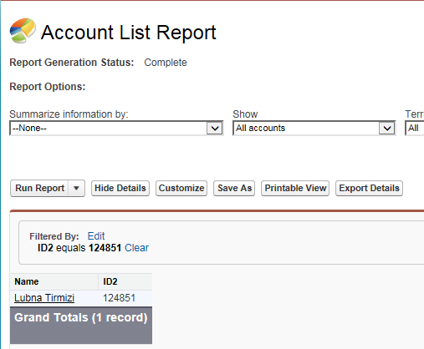

1. Data will display as below

